Blog:

<https://www.webagesolutions.com/blog/archives/5444>

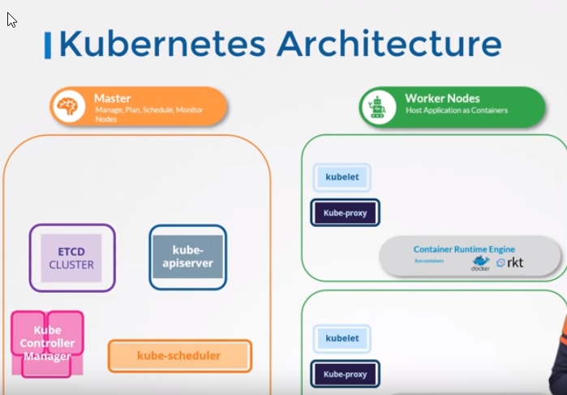

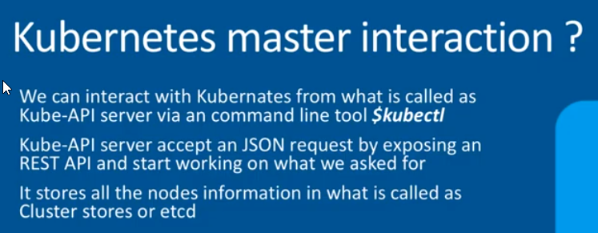

Etcd – maintain info abt containers..it is database that stores in key-value format.

worker nodes -carry containers

kube-scheduler - schduled to load container

operation team..

controller

node -controller

replication controller

kube -api server responsible for orchestrating

kubelet is like manager --communicates with api -server...

kube –proxy

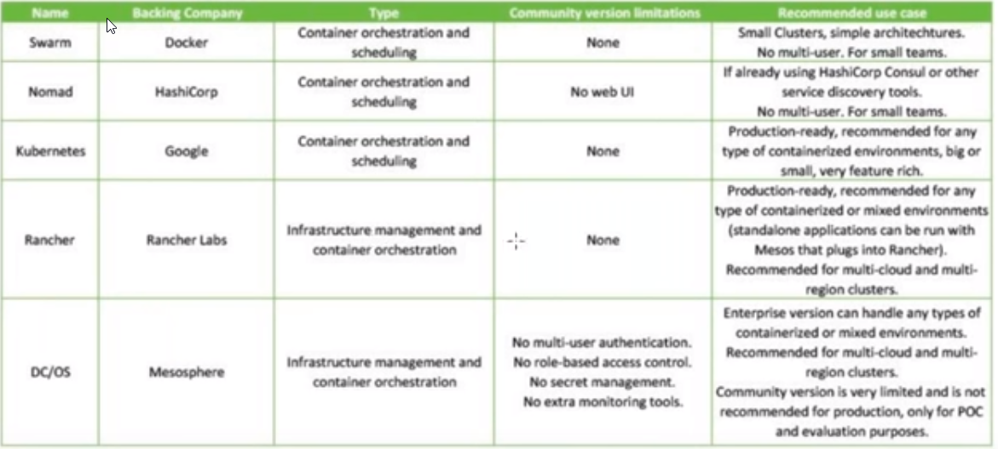

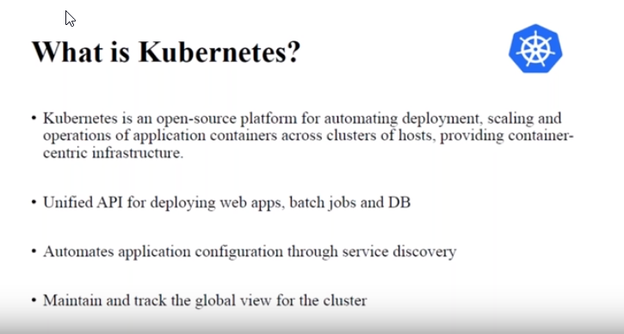

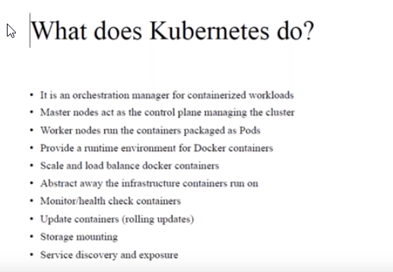

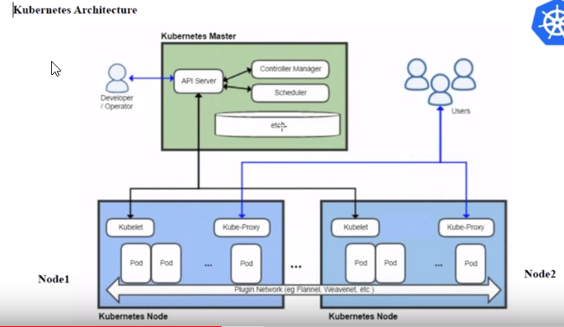

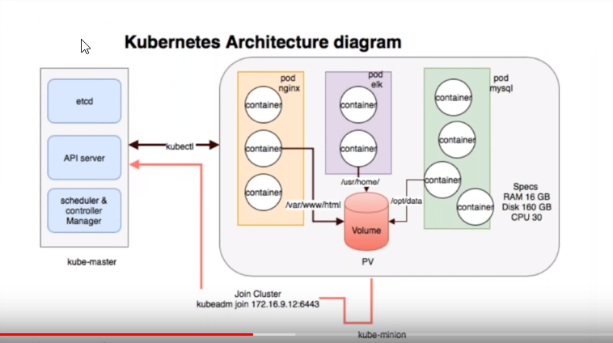

Components in Kubernetes:

Masters and Nodes –

The Kubernetes cluster consists of a set of nodes – which may be physical or virtual servers – on premise or on cloud - that host applications in the form of containers.

Control Pane:

The master node does all of these using a set of components together known as the control plane components.

Master Node components – API server, controller manager, scheduler, etcd.

API Servers:

The cluster Store- Api server is brain. The clustore store is its memory. The cofig and state of the cluster gets persistently stored in the cluster store. The cluster store is based on etcd. The popular distributed, consistent and watchable key-value store. As it is the single source of truth for the cluster, you should take care to protect it and provide adequate ways to recover it if things go wrong.

The controller manager:

Scheduler

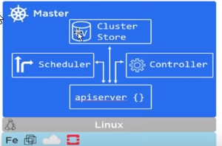

Nodes:- Nodes called as minions.

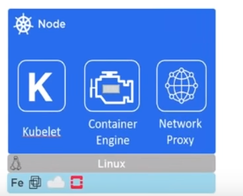

Kubelet – This is the main kubernetes agent that runs on all cluster nodes. If kubelet cannot work, it informs the master / control panel.

Container runtime : The kubelet needs to work with a container runtime to do all the container management like pulling images, starting and stopping containers.

Kube-Proxy – This is like to netowrk brain of the node.It makes sure that each node gets uniaue IP address. It also does light weight load-balancing on the node.

Declarative model and Desired state:

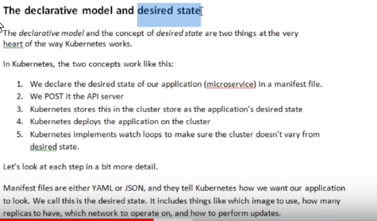

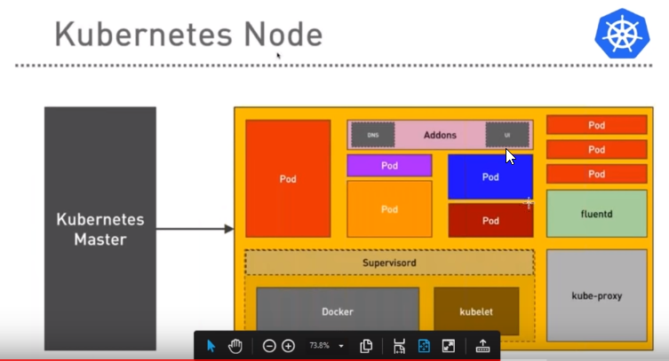

Each Node can have multiple Pods and Each pod can have multiple containers..

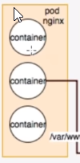

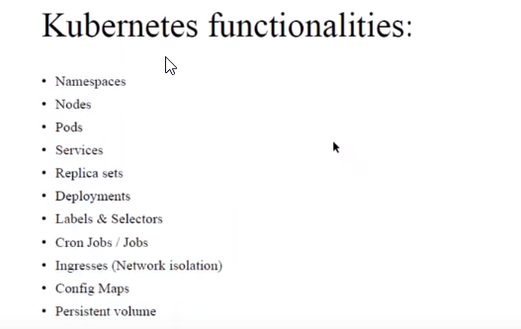

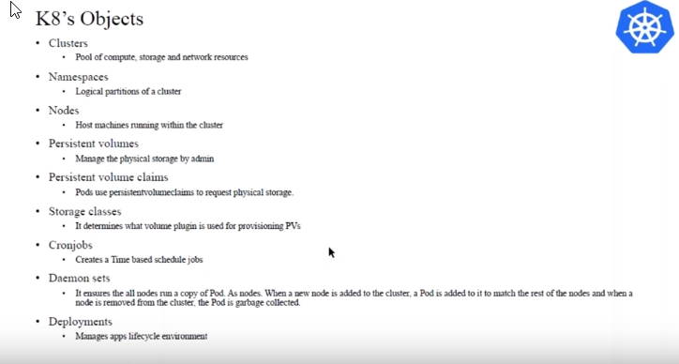

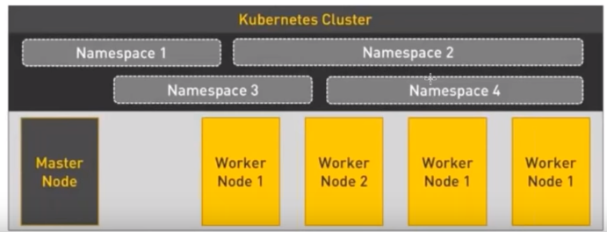

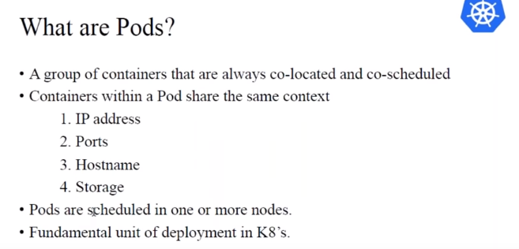

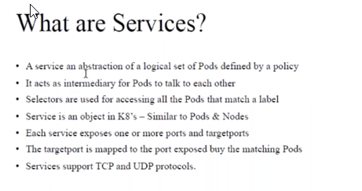

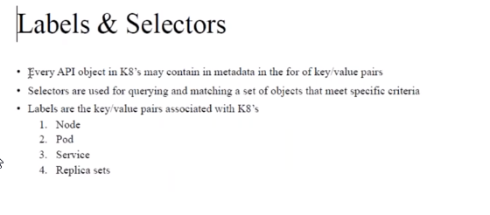

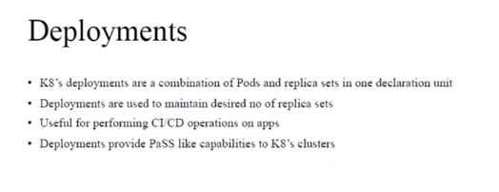

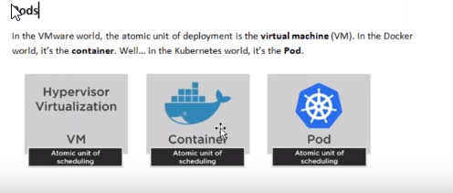

We should not put the same type of container in the same Pod.

If they are separate type, like nginx and Sql container, then we can do it..but it is not recommbded tp have more containers in one pod. Bcoz if pod goes down then both will be shut down.

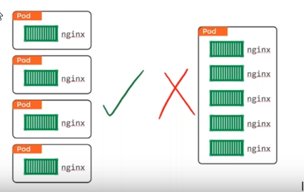

Kubernetes dashboard

<https://github.com/kubernetes/dashboard>

**Installation Kubernetes cluster on AWS**

1. Login AWS account
2. We need 1 Master Node(K8 Server) and 2 Worked Nodes.
3. To Create Master Node(K8 Server) – Launch EC2 instance. It has to be t2 Medium. As it needs atleast 2 cpu core.
4. To create 2 Worker Nodes. – Launch 2 EC2 instances. T2. Micro instance is good.
5. For K8 Server allow security groups- ssh, port80,8080,https443,6783,6784,6443
6. For worker Nodes allow security groups -8083,8081,8080,80
7. Then access your K8 server using ssh or putty.
8. Follow the below steps to install Kubernetes on AWS

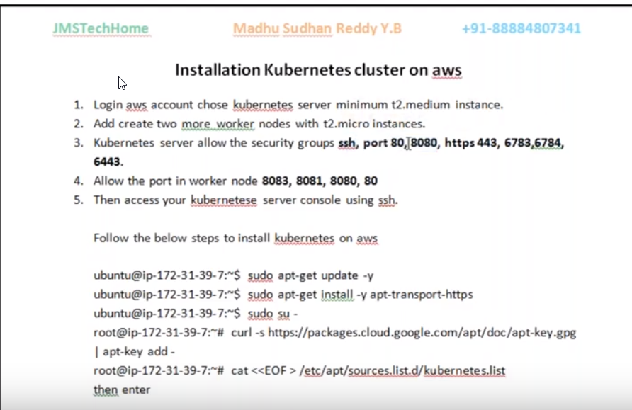

SSH TOOL:

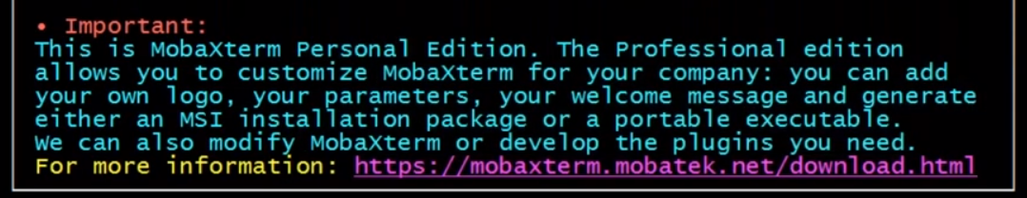

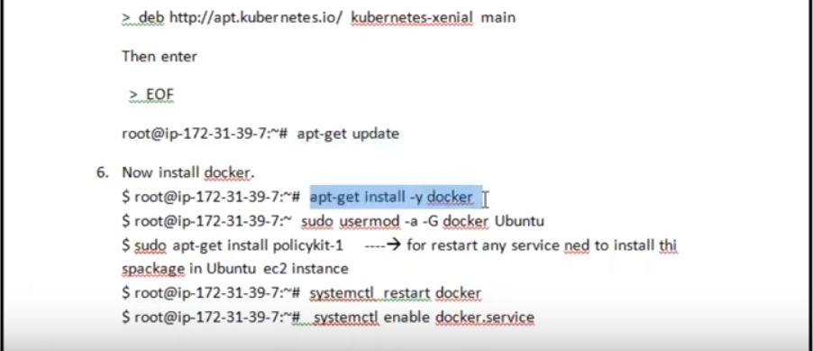

Ubuntu image with instructions

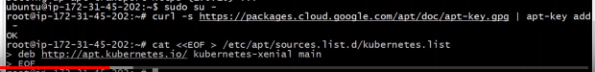

Apt-get update – all updates on kuberntes will be installed.

Now install Kubernetes dependencies..

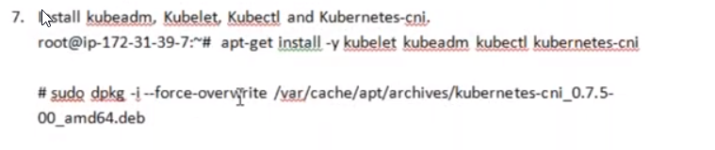

Issue with cni unable to package may occur..for that we have to forecebly overwrite with command..

After overwrite, install gain..

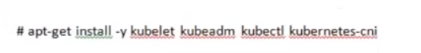

The below commands will install vim, and then add the environment variable for cgroup.

After that create an image. So this can be used to create worker nodes. (So don’t have to install

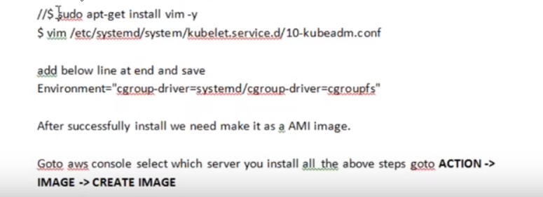

If cgroup is not added , you will see the below error.

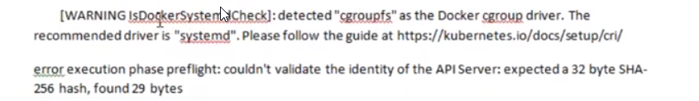

When Creating Image, click ‘ No Reboot’ .Else server will stop.

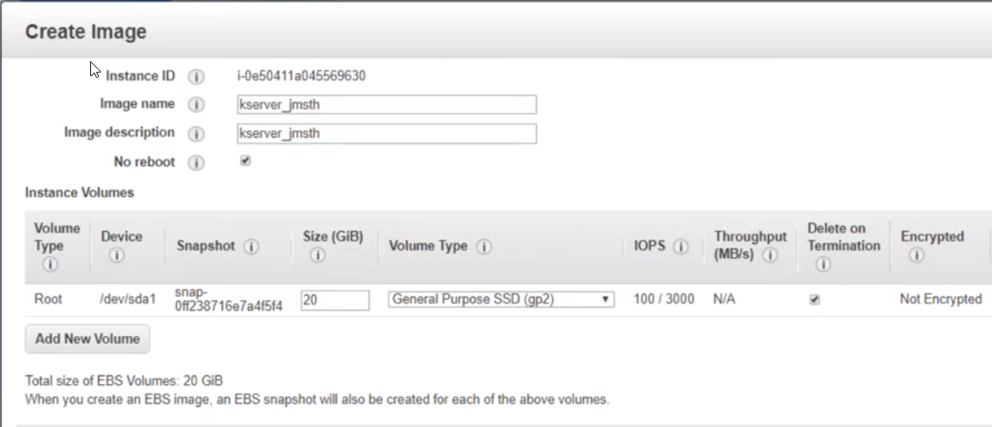

Now initialize kubeadm:

Kubeadm init:

**The master node : kubeadm init is complete now.**

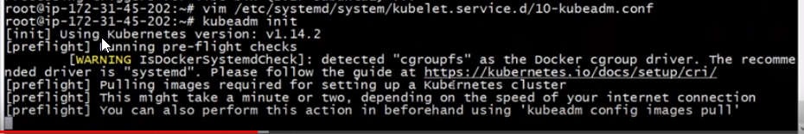

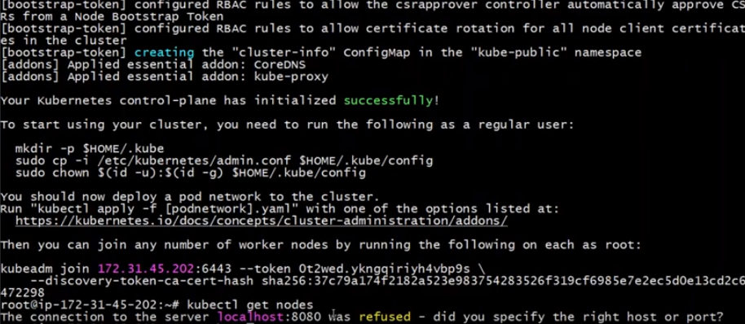

To remove the 8080 refused error, you have to do the below.

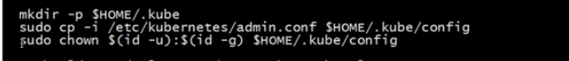

Run: kubectl get nodes. You can see Master node is not ready/ not running..

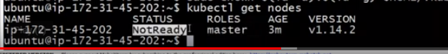

Kubectl get nodes –all –namespaces

Kubectl get pods –all-namespaces

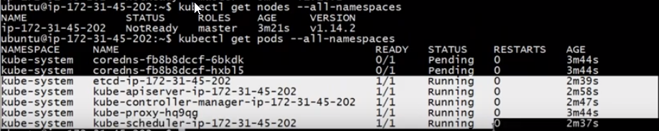

We can see all the components like api-server, controller manager, proxy and scheduler are installed.

Manifest is submitted to api-server, this will be responisble to communicate to worker node.s

But coredns are not running, for that we have to install some packages..

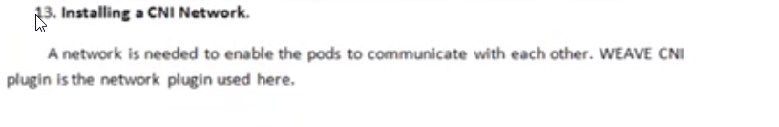

Switch the root user and run : sudo su-

Allow ip tables with below command.



Switch to ubuntu user: su ubuntu

Get the key and assign

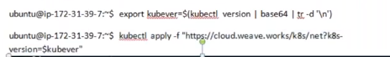

Run: Kubectl get nodes

Master is ready



Kubectl get pods –namespaces

You can see all components are running now.

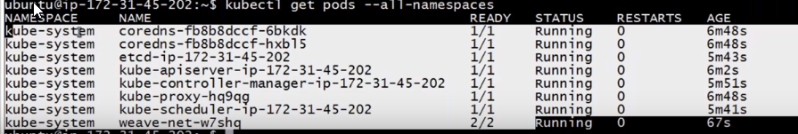

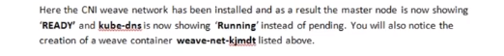

**Now Lets create worker nodes.**

Launch Worker instance. (EC2 – t2-micro)

Take the Image created.

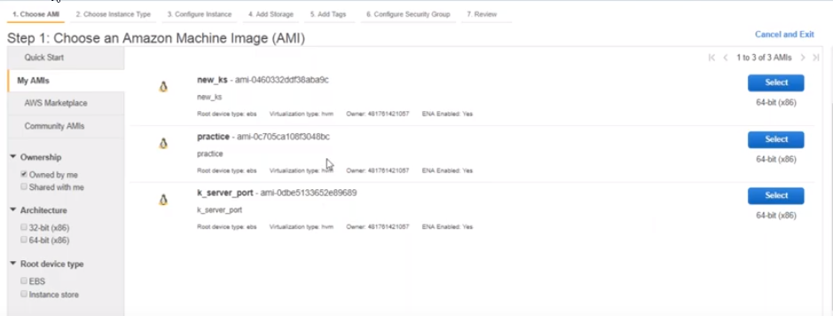

Allow Ports: 8083,8081,8080,80 in the security groups.

Ssh into worker instance.

In the master node while installing you will see this instruction.

To use join command to join any number of worker nodes.

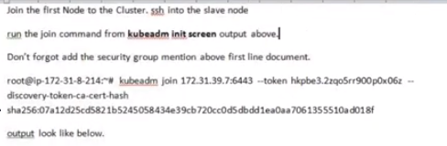

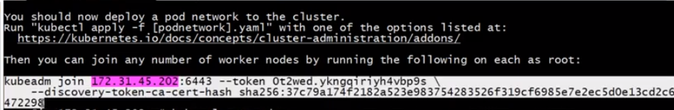

On Master: Type kubectl get nodes

If the node is ready , it wil lshow Ready. Else it will show Not ready.

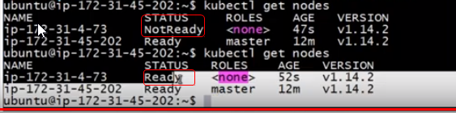

Before running containers, get Kubernetes Dashboard.

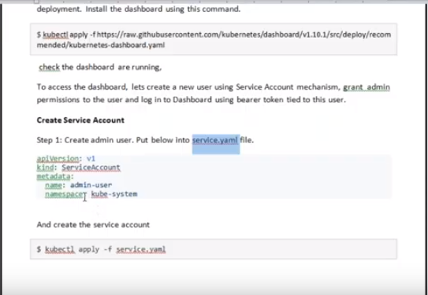

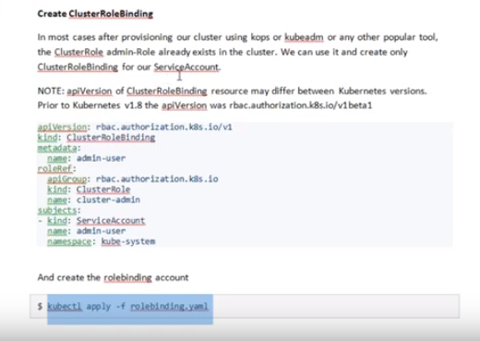

Run this token . evrytime we need to give this token

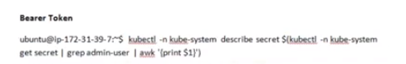

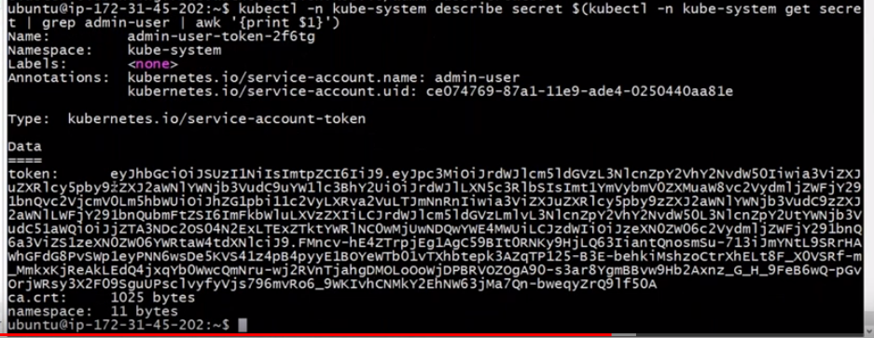

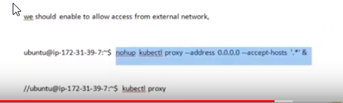

Check which port we need to access the service..



We have to allow the nodeport for accessing outside of the cluster.

We need to change clusterIP to Nodeport.

So edit the kubernetes dashboard service.



You see the yaml file as below..Here we need to change the clusterIP.

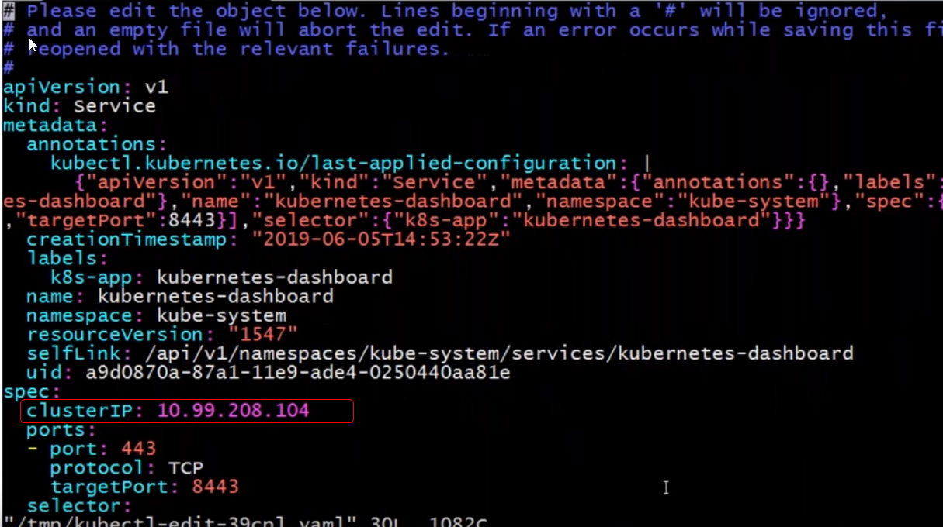

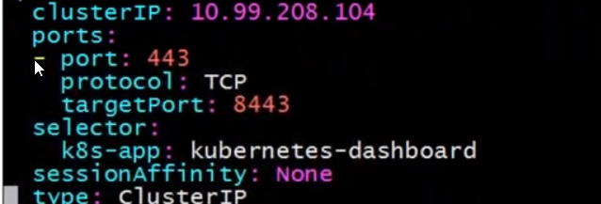

Change type from clusterIP to Nodeport.

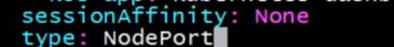

Now check the service: kubectl –n kube-system get service kubernetes-dashboard

You will see the Type is changed from clusterIP to Nodeport. The ports 443:31715/TCP are allowed now.

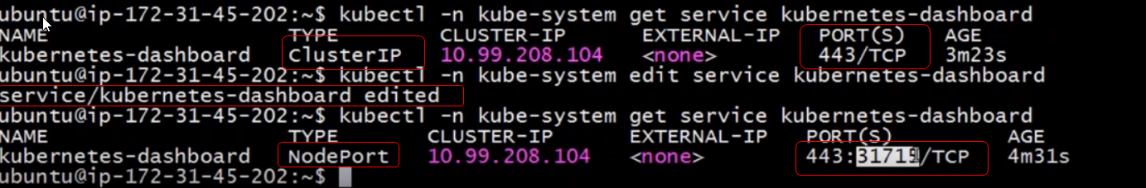

Add the 31715 TCP to allow access in the master node.

Add custom rule in master node security group.

Now try to access the kubernetes dashboard from the Master node:

<https://MasterNodeIpaddress:31715>

Token created above should be enetered to login..

Now Kubernetes dashboard will be available.

Testing to install application..

Kubectl run test –image=ngnix

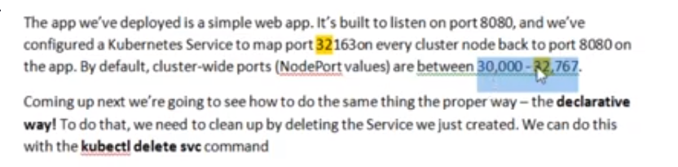

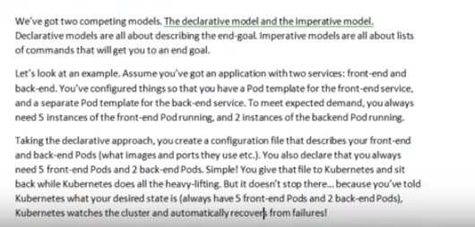

# **Deploy Pods inside cluster.**

1. Type Kubctl get pods

Kuberntes dashboard you can see the status of deployments, pods, Replica sets

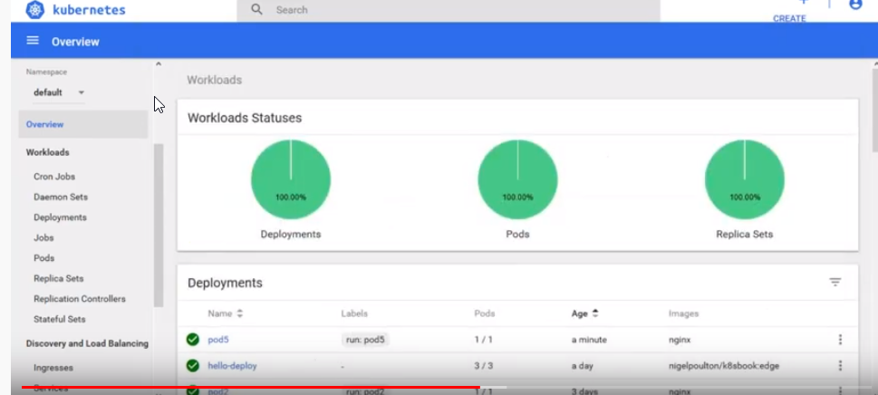

1. Kubectl describe pods <Pod name>

It will show the details of pods..

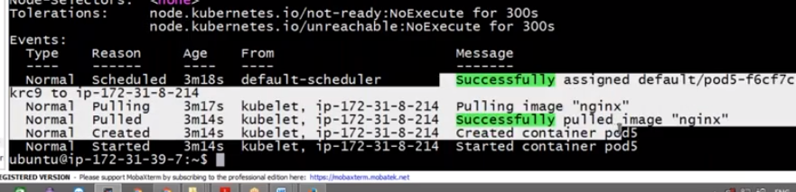

3.Create pod.yml file

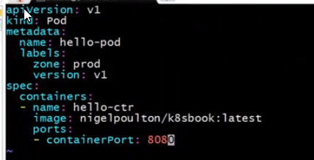

****Api version is based on kubernetes released versions.. check which version will allow the options used

Kind: paramter mentions the type we are createing—pod/deployment, loadbalancer etc..

Zone: Prod

Name—you can name anything

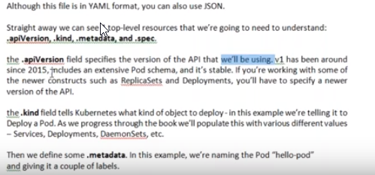

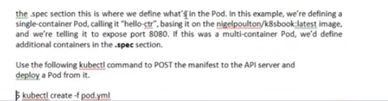

1. Deploy pod:

Kubectl create –f <podname>



Type kubectl get pods

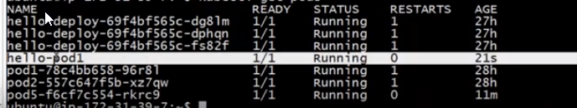

# Install Replica sets:

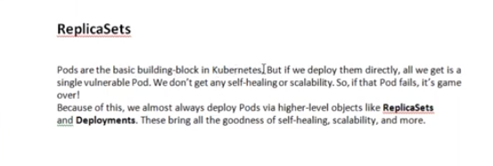

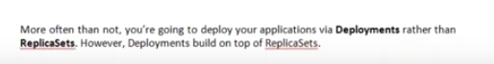

Replicasets only will be scalable. Pods are not scalable..

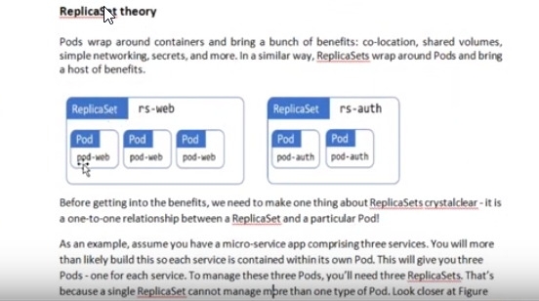

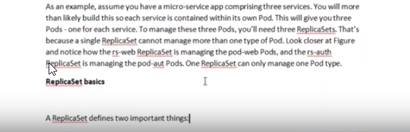

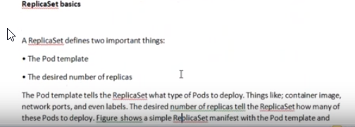

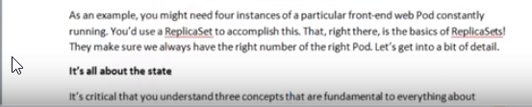

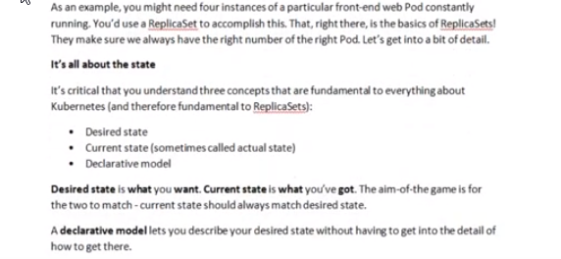

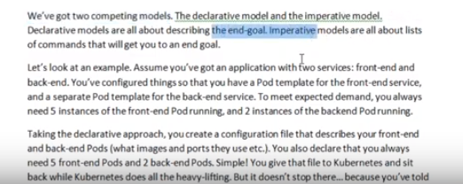

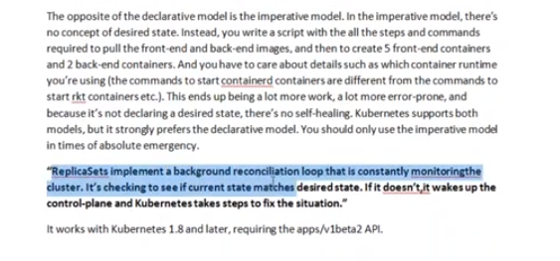

Check any replicaset examples from github

1. Create yml file
2. Create replicaset with the yml file
3. Check if it is created or not by the command – kubectl get pods

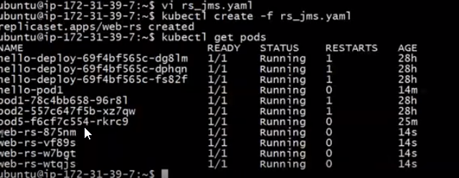

References:

1. <https://www.tutorialspoint.com/kubernetes/index.htm>
2. <https://www.vultr.com/docs/getting-started-with-kubernetes-on-centos-7>
3. <https://www.howtoforge.com/tutorial/how-to-install-kubernetes-on-ubuntu/>
4. Nigelpoulton – k8sbook.